ASSIGNMENT # 1

Tasks Related to List

# task # 1

**Names:** Store the names of a few of your friends in a list called names. Print each person’s name by accessing each element in the list, one at a time.

## program

'''

Name: Mubashir Ali

Batch: 03

Sec: A

'''

#Print names one at a time.

names=['abdullah','bashir','saeed','tahir','zubair']

print(names[0])

print(names[1])

print(names[2])

print(names[3])

print(names[4])

## output

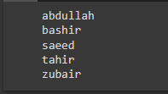

# task # 2

**Greetings:** Start with the list you used in **Task 1**, but instead of just printing each person’s name, print a message to them. The text of each message should be the same, but each message should be personalized with the person’s name.

## program

#Greeting each person using concatination.

names=['abdullah','bashir','saeed','tahir','zubair']

print("Hello",names[0]+"!")

print("Hello",names[1]+"!")

print("Hello",names[2]+"!")

print("Hello",names[3]+"!")

print("Hello",names[4]+"!")

## output

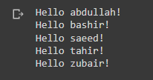

# task # 3

**Your Own List:** Think of your favorite mode of transportation, such as a motorcycle or a car, and make a list that stores several examples. Use your list to print a series of statements about these items, such as “I would like to own a Honda motorcycle.”

## program

#Making list of cars and printing statements about them.

cars=['honda','bmw','lamborghini','tesla','rolls-royce']

print(cars[0].capitalize(),"cars are pretty popular in Pakistan.")

print(cars[1].upper(),"is known for making luxurios vehicles.")

print("If you own a",cars[2].capitalize()+", then you are showing off.")

print("You don't have to drive",cars[3].capitalize()+", it can drive itself.")

print("You can't own a",cars[4].title(),"unless you belong to a royal family.")

## output

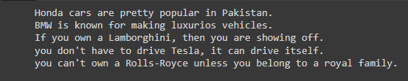

# task # 4,5,6 and 7

## program

#Task 4

#Guest list.

names=['abdullah','ayesha','saeed']

print("Hello",names[0].capitalize()+", i would like to invite you to dinner.")

print("Hello",names[1].capitalize()+", i would like to invite you to dinner.")

print("Hello",names[2].capitalize()+", i would like to invite you to dinner.")

#Task 5

print("\n"+names[1].capitalize(),"can't make it to dinner.\n")

#Replacing ayesha with tooba using remove and insert function.

names.remove("ayesha")

names.insert (1,"tooba")

print("Hello",names[0].capitalize()+", i would like to invite you to dinner.")

print("Hello",names[1].capitalize()+", i would like to invite you to dinner.")

print("Hello",names[2].capitalize()+", i would like to invite you to dinner.")

#Task 6

#Inserting More guests using insert and append function.

print("\nWe got a bigger table!\n")

names.insert (0,"amna")

names.insert (2,"bushra")

names.append ("zubair")

print("Hello",names[0].capitalize()+", i would like to invite you to dinner.")

print("Hello",names[1].capitalize()+", i would like to invite you to dinner.")

print("Hello",names[2].capitalize()+", i would like to invite you to dinner.")

print("Hello",names[3].capitalize()+", i would like to invite you to dinner.")

print("Hello",names[4].capitalize()+", i would like to invite you to dinner.")

print("Hello",names[5].capitalize()+", i would like to invite you to dinner.")

#Task 7

#Popping out guests using pop function.

print("\nSorry guys i can invite only two people.\n")

name=names.pop()

print("Sorry",name.capitalize()+", there is no room at the dinner table.")

name=names.pop()

print("Sorry",name.capitalize()+", there is no room at the dinner table.")

name=names.pop()

print("Sorry",name.capitalize()+", there is no room at the dinner table.")

name=names.pop()

print("Sorry",name.capitalize()+", there is no room at the dinner table.\n")

print(names[0].capitalize()+", you are still invited to dinner.")

print(names[1].capitalize()+", you are still invited to dinner. ")

#Empty out the list using del function.

del(names[0])

del(names[0])

print(names)

## output

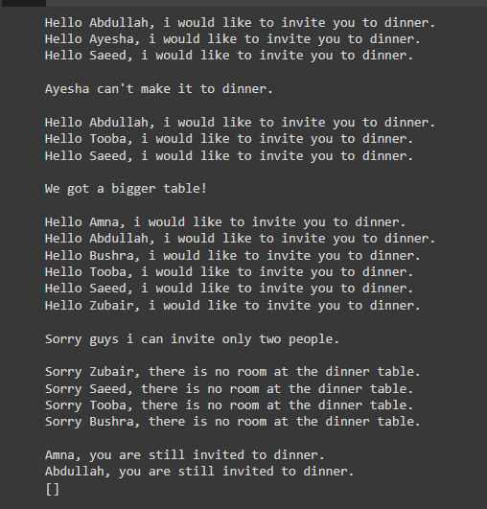

# task # 8

## program

#Seeing the world.

places=['Zimbabve','Arizona','Malaysia','Newyork','Egypt']

print('Original list\n'+str(places))

#Using sorted to sort list temporarily.

print("\nSorted list\n"+str(sorted(places)))

print('\nOriginal list\n'+str(places))

#Temporarily sorting listin reverse using sorted function.

print('\nReverse sorted list')

print(sorted(places,reverse=True))

print('\nOriginal list\n'+str(places))

#Reversing list permenantly using reverse function.

places.reverse()

print('\nReversed list\n'+str(places))

#Reversing list again.

#places.reverse()

print('\nOriginal list\n'+str(places))

#Sorting list permenantly using sort function.

places.sort()

print('\nSorted list\n'+str(places))

#Reverse sorting list permenently.

places.sort(reverse=True)

print('\nSorted list\n'+str(places))

## output

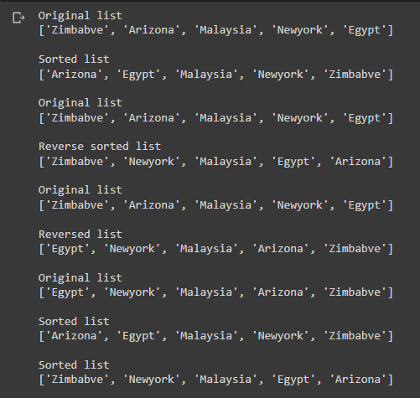

# task # 9

## program

#Dinner guests

names=['abdullah','ayesha','saeed','tooba','zubair']

#Counting number of guests invited using len function

print('Number of guests invited: '+str(len(names)))

## output



# task # 10

## program

#Every function

x=["cat",2.5,500,"bmw"]

print(x)

x[1]="dog" # changing first element of x from 2.5 to dog

print(x)

bike=["honda","yamaha","suzuki"]

del bike[1] #deleting the value at index 1 from bike

print(bike)

x=["cat",2.5,500,"bmw"]

x.insert(1,"dog")#it inserts the element in given position

print(x)

x.append("mazda")#it will append the element at last

print(x)

y=x.pop(2)#it will pop that element out at given index and remove from that list If no index is specified

print("popped "+str(y))

print(x)

x.remove("bmw")#it will remove the given elment from the list

print(x)

list_one = [1, 2, 3, 4, 5, 6, 7]  # This is the first list

list_two = [10, 12, 14]           # This is the second list

list_one.extend(list_two)         # Extend list_one by appending all items of list_two

print(list_one)

my_list = ["zero", "one", "two", "three", "four", "five"]        # Create a list

my_list.reverse()                                                # Reverse the items of the list in place

print("Reversed list\n"+str(my_list))

my_list.sort(reverse=True)                             #it will sort list in descending order

print(my_list)

my_list.sort()                             #it will sort list in ascending order

print(my_list)

my_list = ['two', 5, 'one', 2]                #Counting number of elements in list

print(len(my_list))

my_list = [5, 3, 6, 1, 2, 4, 7]           # Create a list

sorted(my_list, reverse=True)             # Sorted the items of the list temporarily

print("Sorted list\n"+str(my_list))

## output

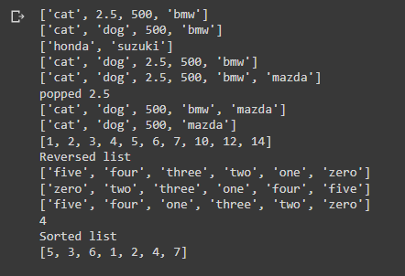

# task # 11

## program

#Intentional error

num = ["zero", "one", "two", "three", "four", "five"]

del num [6]        #IndexError: list assignment index out of range

num[:]

## program(correction)

#Correction of error

num = ["zero", "one", "two", "three", "four", "five"]

del num [5]

num[:]

## output

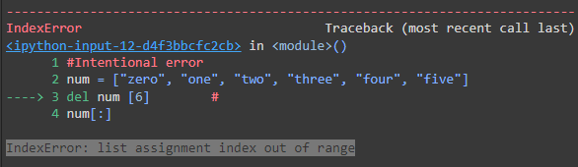

## output(Correction)



Tasks Related to String & Input() Method

# task # 1

## program

name=input(print("Enter a string: "))  #Taking string input.

print("Hello "+name+"!")  #Concatenation using "+".

## output

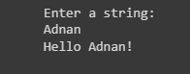

# task # 2

## program

str1="bum"

str2="chiki"

print(str1+str2*2+str1)

## output



# task # 3

## program

str1=input("Enter a string: ")

if len(str1)>=2:  #Checking if string's length is less than 2.

  print(str1[-2:]*3)  #Slicing string using indexes.

else:

  print ("string's length is less than 2")

## output



# task # 4

## program

str1=input("Enter a string: ")

print(str1.replace(" ",""))  #Replacing whitespaces using replace function.

## output



# task # 5

## program

str1=input("Enter a string: ")

if len(str1)>=2:

  print(str1[0:2])

elif len(str1)<2:

  print(str1)

else:

  print("")

## output



# task # 6

## program

str1=input("Enter a string: ")

if len(str1)%2==0:  #Checking if lenght of string is an even number.

  str2=str1[:int(len(str1)/2)]  #Saving first half of string using slicing.

  print(str2)

else:

  print ("string's length is an odd number")

## output

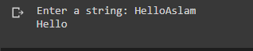

# task # 7

## program

str1=input("Enter a string: ")

if len(str1)>=2:

  print(str1[1:-1])  #Printing string except first and last letter using slicing.

else:

  print ("string's length is less than 2")

## output



# task # 8

## program

str1=input("Enter first string: ")

str2=input("Enter second string: ")

print(str1[1:]+str2[1:])

## output

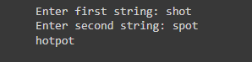

Tasks Related to Number & Input() Method

# task # 1 (A)

Think multiple complicated mathematical (algebric and trigonometric) formulas and solve them using Number built in methods in Python.

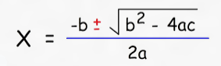

## program

import math

a=int(input("Enter value for \"a\"= "))

b=int(input("Enter value for \"b\"= "))

c=int(input("Enter value for \"c\"= "))

s1=math.pow(b,2)

s2=4*a*c

s3=2*a

x1=(-b+math.sqrt(s1-s2))/s3

x2=(-b-math.sqrt(s1-s2))/s3

print ("first value=",x1)

print ("second value=",x2)

## output

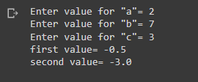

# task # 1 (B)

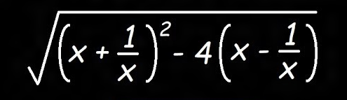

## program

import math

x=int(input("Enter value for \"x\"= "))

s1=x+(1/x)

s2=x-(1/x)

x=math.sqrt(math.pow(s1,2)-4*s2)

print ("Answer=",x)

## output

